

**BLG 632E**

**NEXT GENERATION**

**WIRELESS NETWORKS**

CRN: 23552

INSTRUCTOR: IRFAN ALI

**ASSIGNMENT #1**

Date: 21.02.2017

STUDENT NAME: TUĞRUL YATAĞAN

STUDENT NUMBER: 504161551

**1.1)**

Subnet-2 is 192.168.4.0/24

Bits representation: 1111 1111 1111 1111 1111 1111 0000 0000

Decimal representation: 255 . 255 . 255 . 0

**1.2)**

Subnet-2 is 192.168.4.0/24

IP address 192.168.3.0 does not belong to Subnet-2 since:

192.168.3.0 BITWISE AND 255.255.255.0 is not equal to 192.168.4.0

**1.3)**

Subnet-2 is 192.168.4.0/24

32-24=8 bit for all IP address in subnet. 2^8=256 IP address. Except first and last 256-2=254

First IP in subnet is 192.168.4.0

Last IP in subnet is 192.168.4.256

**1.4)**

192.168.8.0/24 **11000000.10101000.0000**1000.00000000

192.168.4.0/24 **11000000.10101000.0000**0100.00000000

Summarize

192.168.0.0/20 **11000000.10101000.0000**0000.00000000

**1.5)**

192.168.8.0/24 **11000000.10101000.0000**1000.00000000

192.168.4.0/24 **11000000.10101000.0000**0100.00000000

192.168.2.0/24 **11000000.10101000.0000**0010.00000000

192.168.2.0/24 **11000000.10101000.0000**0001.00000000

Summarize

192.168.0.0/20 **11000000.10101000.0000**0000.00000000

**2.1)**

msc {

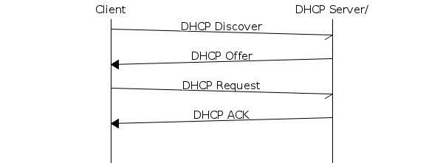

arcgradient = 8;

a [label="Client"],b [label="DHCP Server"];

a->* [label="DHCP Discover"];

a<=b [label="DHCP Offer"];

a->* [label="DHCP Request"];

a<=b [label="DHCP ACK"];

|||;

}

DHCP Discover: Client broadcasts messages on the network to IP address lease request.

DHCP Offer: Server reserves an IP address and sends an IP address offer to the client.

DHCP Request: Client broadcasts that requesting the offered IP address.

DHCP acknowledgement: Server sends acknowledgement to client.

**2.2)**

ARP probe after DHCP exchange checks if newly obtained IP address has been assigned to another node before. Possible IP conflict will be prevented.

**2.3)**

When type fake/unknown website in my browser, my DNS client communicates to 8.8.8.8 and 8.8.4.4 which are my operating system’s DNS server settings.

In my case DNS address is not provided in the DHCP response from the DHCP server.